Biographies for Gareth D Morewood (updated March 2016)
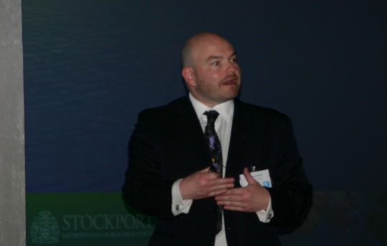
website - www.gdmorewood.com
e-mail - info@gdmorewood.com
twitter - @gdmorewood
blog - SENCology

Short (47 words)

Gareth is Director of Curriculum Support (SENCo) & Specialist Leader of Education at Priestnall School, Stockport and Honorary Research Fellow in Education at the University of Manchester. He has authored a number of articles, books, academic papers and publications which can be found on his website www.gdmorewood.com.

Medium (154 words)

Gareth D Morewood has been the Director of Curriculum Support (SENCo) at Priestnall School in Stockport since September 2002. During this time he has shaped provision not only at Priestnall but also in a number of other schools and Local Authorities across the UK and Ireland through support, research, training and consultancy. Gareth also regularly supports parents/carers with SEND legislation and provision, as part of his wider interests in equality and opportunity for all.

Gareth has written extensively on his philosophy of inclusive education and provision over the past few years and regularly speaks at and chairs national conferences on provision within mainstream settings for students with complex needs.

Through his research, extensive knowledge and practical experience in developing whole-school approaches to supporting young people with autism in mainstream schools, Gareth has considerable experience in the development of evidence-based whole-school inclusive systems. He can be contacted via his website (www.gdmorewood.com) or on e-mail info@gdmorewood.com.

Full (305 words)

Gareth D Morewood has been the Director of Curriculum Support (SENCo) at Priestnall School in Stockport since September 2002. During this time he has shaped provision not only at Priestnall but also in a number of other schools and Local Authorities across the UK and Ireland through support, research, training and consultancy. Gareth also regularly supports parents/carers with SEND legislation and provision, as part of his wider interests in equality and opportunity for all.

As a passionate advocate for inclusive education, Gareth has written extensively on his philosophy of inclusive education and provision over the past few years and regularly speaks at and chairs national conferences on provision within mainstream settings for students with complex needs. You will find links to most of his papers, articles, books and films on his website, along with a number of resources that are freely available to use and adapt, as required.

Through his research, extensive knowledge and practical experience in developing whole-school approaches to supporting young people with autism in mainstream schools, Gareth has considerable experience in the development of evidence-based whole-school inclusive systems.

Currently, Gareth’s additional roles include:

- Independent Chair of Essex SEND Innovations Project (2014-2016)
- Member of the Strategic Advisory Group for the KIDS MiP3 Project (2015-2016)
- Designated a Specialist Leader of Education
- Honorary Research Fellow in Education, The University of Manchester
- Associate Editor of the Good Autism Practice Journal
- Member of the Optimus Education Editorial Board
- Vice-Chair of the DfE-hosted ‘senco-forum’ Advisory Group

In addition to direct school-to-school support and training, Gareth has recently started working with groups of schools, Local Authorities and CAMHS teams in developing more effective support systems across the UK and in Ireland. To ask Gareth about the possibility of supporting you, visit the Training & Consultancy tab on his website (www.gdmorewood.com) or e-mail info@gdmorewood.com.

