Following on from the training delivered by Elizabeth Hallows (www.elizabethhallows.co.uk), this summary sheet is provided for staff to support backcare management in the workplace.
Known Ergonomic Risk Factors for Developing M.S.D.s [musculoskeletal risk] are ...  - Awkward or Static Postures  - Repetitive Tasks  - Having to use excessive Force  - Hours Worked  - Lifting  (Li and Buckle 1999)  Remember to pull and push objects instead of lifting, whenever possible. | Setting up your computer workstation/desk  Sit down with your bottom to the back of the chair.  Move the chair in close to the desk and relax back against the back rest.  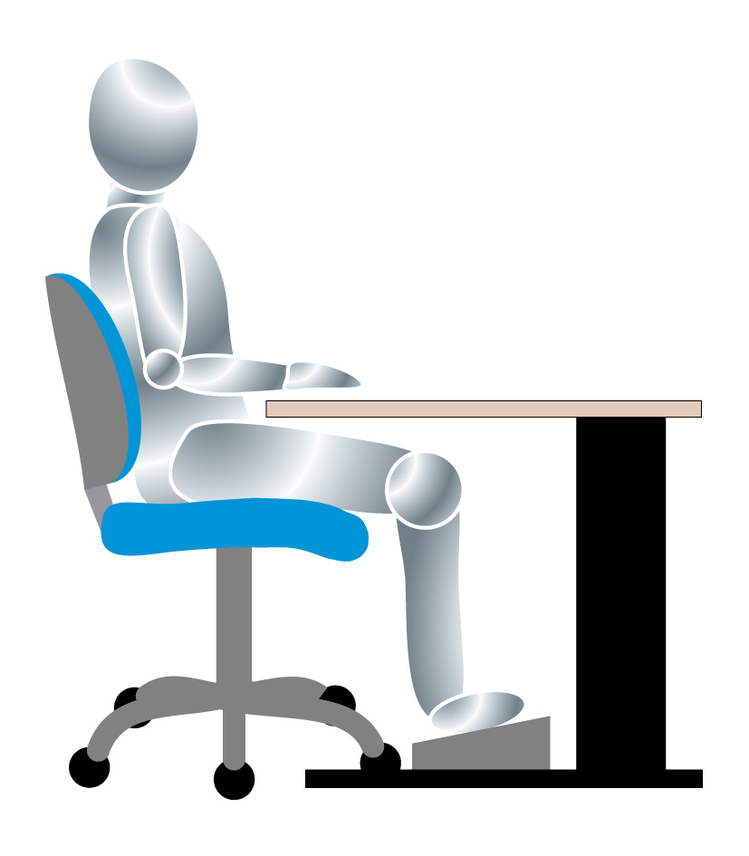  Adjust the height of the back rest so that the lumbar support is at the correct height for your back.  Adjust the height of the chair so that with your fingertips on the keyboard, your shoulders are relaxed, your upper arms vertical, and your forearms horizontal.  Having adjusted your chair to the right height for your hands/arms and shoulders, then use a footrest if your feet do not rest comfortably on the floor.  Position the monitor screen so that it is directly in front of you, around an arm’s length away.  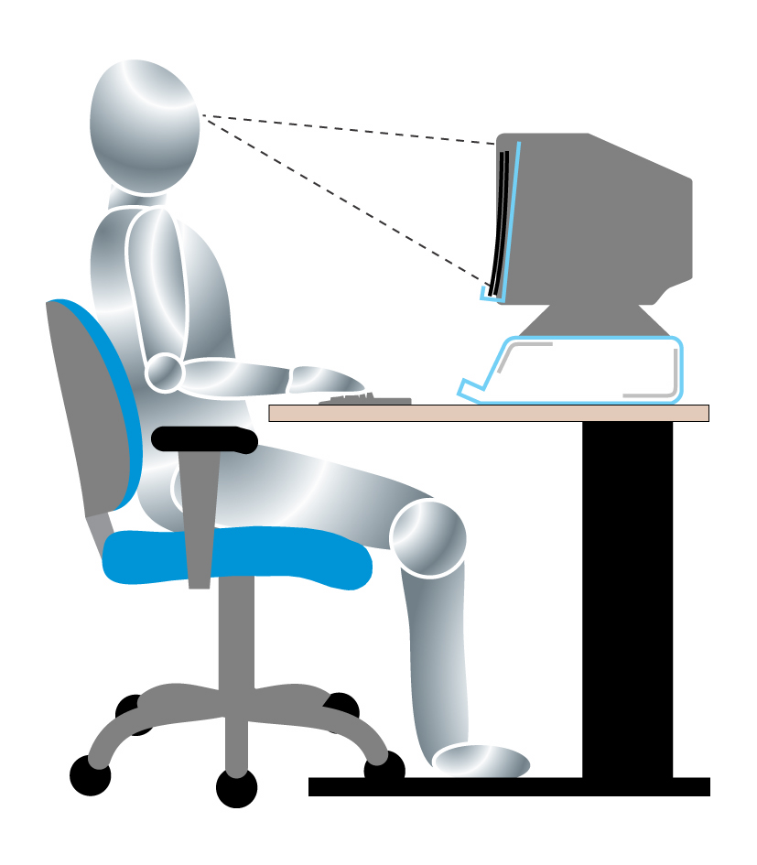  If you can touch type, have the top of the screen around eye level.  If you need to look down at the keys and up at the screen, have the monitor a little lower.  Move your mouse/phone within easy reach – so you are not stretching.
Guidance for lifting in the workplace
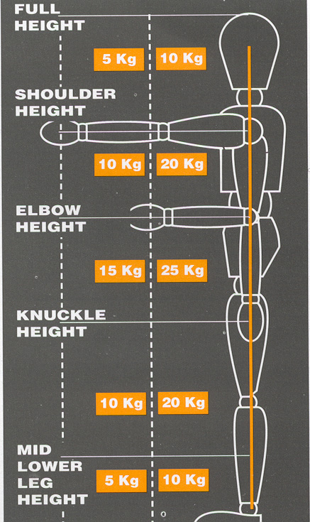

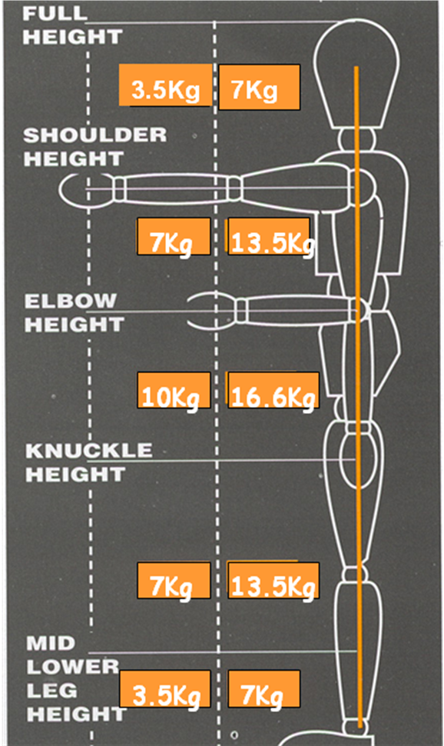
MEN WOMEN
Wherever possible do not life anything above these guides. Ask for assistance from colleagues, or schedule support from Site Maintenance Staff. Plan any lifting/moving to ensure support is requested in advance.
If you need specific advice or additional support please ask Gareth D Morewood, Director of Curriculum Support. Should there be simple adjustments in line with the training and advice provided, please seek support from your line manager, in the first instance.

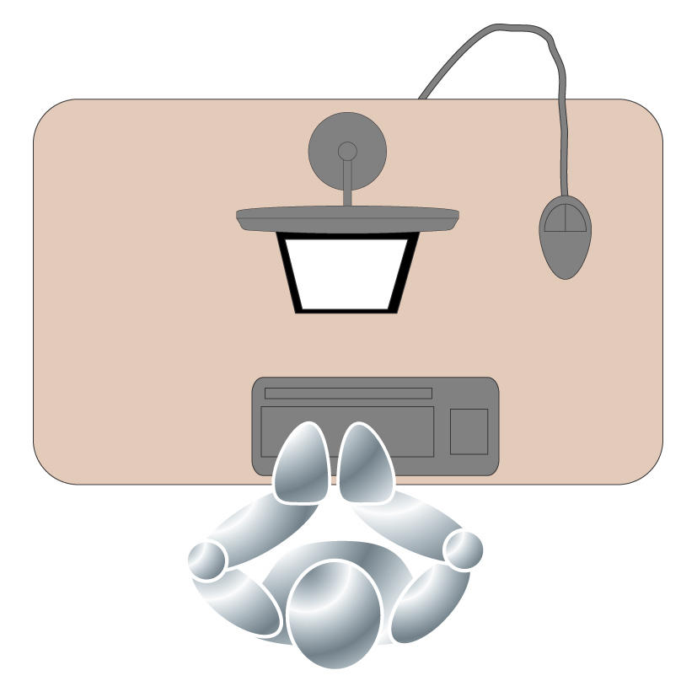
Posture – when sitting aim for upright spine, shoulders over hips and use writing slope for paperwork – level arch file will do!

Computer set-up – try and ensure the screen is in line and not on an angle.

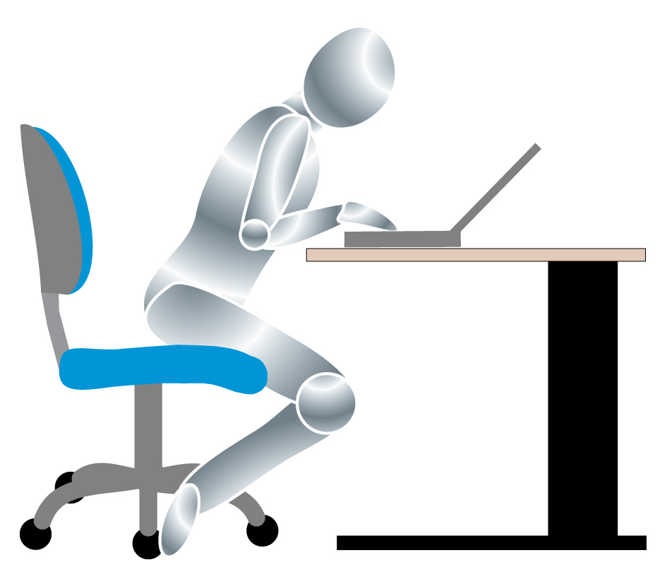

Do not ‘lean over’ your computer/marking; remember to keep your back upright.

